Abstract format – place your title here formatted as shown here in bold: use Times New Roman font and do not capitalise first letters or whole title

R Gruber1,2, A Sculean2

1 [Department of Oral Biology](mailto:reinhard.gruber@meduniwien.ac.at), School of Dentistry, [Medical](http://www.aofoundation.org/) University of Vienna, Austria.

2 [Department of Periodontology](mailto:anton.sculean@zmk.unibe.ch), School of Dental Medicine, University of Bern, Switzerland

**INTRODUCTION:** The abstracts **must** adhere to the contained style. The styles illustrated in this Microsoft WORD document must be used as a template for production of abstracts. Replace the relevant text with your own by cutting and pasting of unformatted text to maintain the present format. IMPORTANT: DO NOT INTERFERE WITH HEADER OR FOOTER.

**METHODS:** All abstracts must be formatted to a **single** A4 page (210 x 297 mm). The top margin should be set to 15 mm, bottom margin to 25 mm, and 1eft and right margins to 20 mm. The entire document is set to 2 columns with 10 mm of intercolumn spacing (giving a column width of 80 mm). The body of the document should be set in 11pt Times New Roman with single line-spacing. Do not use fonts other than Times New Roman or Symbol in the document (including equations and figures).

*Title* should be in bold, styled as shown. *Authors* should be listed consecutively (as above) by initials and last name, punctuated as shown. Authors may be hyperlinked to the e-mail address (as shown above). *Affiliation* should be indicated with superscipted suffix Arabic numerals. Do not append degrees, professional designations, etc., to names. Affiliations should be listed consecutively and may be hyperlinked to a web page or email address (as examples above). Sample reference entries [l-2] are given in the References section. References should be set as one block, as below, and a maximum of three references may be used.

**RESULTS:** Figures should use *Figure* style and have the caption below them. Tables should use *Table* style and have the caption above them. Figure and table caption styles are *FigCaption* and *TableCaption*, respectively. Scanned figures should have a minimum resolution of 200 dpi for an 80 mm figure width. Equations should use *Equation* style:

*J = -cD dx/dz* (1)

and should be tab centred, with the number in parentheses on the right.

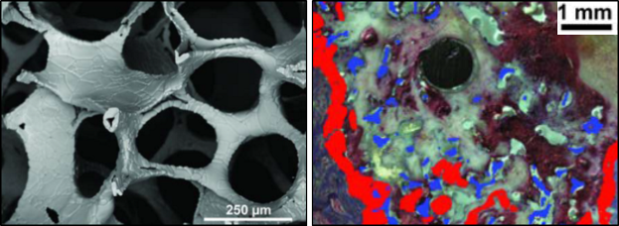

Fig. 1: Images of scaffolds for bone repair in this case – please compress images to 200dpi before saving. Include scale and unit if not already embedded in the image.

Table 1. Relative resorption rate and cell toxicity of materials used.

|  |  |  |
| --- | --- | --- |
|  | Resorption rate | Cell toxicity |
| Collagen | high | low |
| Sintered Hydroxyapatite | low | low |

**DISCUSSION & CONCLUSIONS:** Abstracts must not exceed one page. Do **NOT** tamper with the header or footer. Please submit the abstract as a PDF document. Only electronic submissions will be accepted. The abstracts must be submitted via the submission system on the Foundation’s global community platform THE BOX ([www.box.osteology.org](http://www.box.osteology.org)).

**REFERENCES:** 1 Kuchler, U., et al. (2015). *Dimethyloxalylglycine lyophilized onto bone substitutes increase vessel area in rat calvarial defects*. Clinical Oral Implants Research 26(5): 485-491. 2 Schwarz, F., et al. (2014). *Immunohistochemical characteristics of regenerated bone after surgical therapy of advanced ligature-induced peri-implantitis defects*. Clinical Oral Investigations 18(6): 1679-1686.

**ACKNOWLEDGEMENTS:** This template was modified with kind permission from eCM Journal. Please acknowledge technical or funding support and declare possible conflicts of interests.